T/TR 11:30-12:50

**Klinger comment: This homework is very well done. The one thing that would make it even better is market data. How big is the market for beverages? What is their market share? Sometimes this data is hard to find.**

Homework #5

December 8th, 2016

Sara Mantz

Daisry Joy Ladignon

Elizabeth Guy

James Coulson

**Honest Beverages**

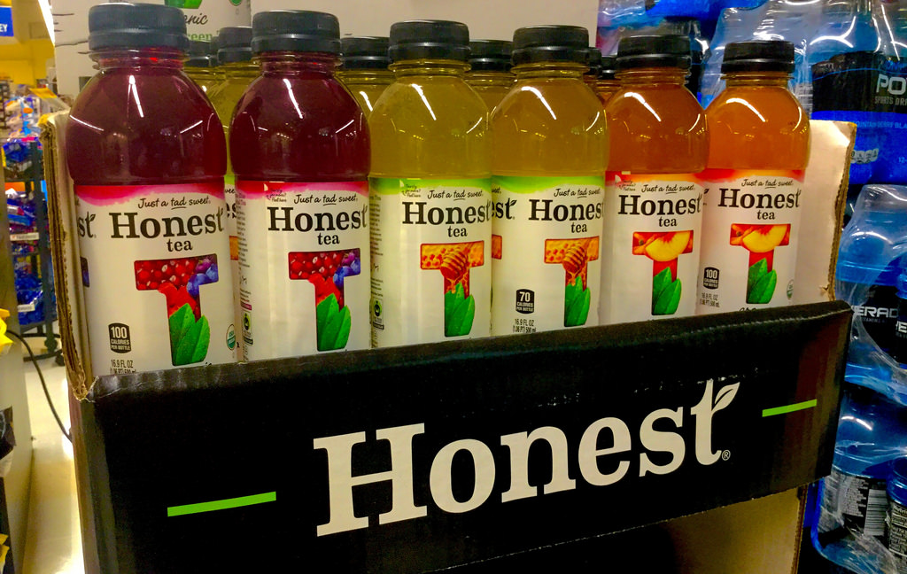

The brand Honest was founded in 1998, and bought by Coca-Cola in 2011. Before their rise to fame, the company’s founders would sell samples of their low-sugar at Whole Foods. Since their start, Honest has centralized their mission on making healthy and organic teas. Their 2010 mission statement says “we strive to grow our business with the same honesty and integrity we use to craft our products, with sustainability and great taste for all.” Many people are now opposing highly sugary drinks, and Honest has been ahead of this trend.

As the company continues to grow, their sales have increased 20% from 2014 to 2015. With the additions of new products to their beverage line over the years, especially Honest Kids, their new children's drink has redefined a sugary, sweet beverage. Other drinks ranging from zero calorie to summer refreshers have built the business into a $160 million division of Coca-Cola. Now, in 2016, Honest is moving closer into the mass market. Honest Tea products are now in 100,000 stores across the country.

1. **Honest Beverages**

Honest is America’s #1 organic bottled tea line. Honest offers great-tasting refreshing drinks with a variety of organic teas, ades (lemonades, limeades etc.), and kids beverages. Honest drinks are freshly brewed using organic tea leaves and organic cane sugar. Each tea variety is Certified Organic, OU Kosher and Fair Trade Certified. Honest Ade, Honest Splash and Honest Kids are Certified Organic, caffeine-free thirst quenchers.

Their target market is not the younger audience because their drinks are not as highly sweetened as other drinks. Their target market is generally an older audience. Being that Honest Tea has 7 different types of products in their arsenal, we thought it would be a good choice simply because of the varied product line.

**Honest beverages product line:**

* **Honest Tea**
  + Iced teas that are certified organic, 100 calories or less per bottle and all of these teas are slightly sweetened.
* **Glass Bottles**
  + The organic iced tea line that started it all. These teas range in flavor and sweetness, but are all 70 calories or less per bottle and brewed with Fairtrade tea and sugar.
* **Honest Kids**
  + Organic juice drinks bursting with tasty goodness. Sweetened only with organic fruit juice.
* **Honest Fizz**
  + Naturally sweetened sodas with zero calories and zero sugars.
* **Summer Refreshers**
  + Organic Lemonades, a Limeade and a Half & Half in family-sized bottles, sweetened with fair trade sugar.
* **Honest Sport**
  + Honest Sport combines organic fruit juices and Fair Trade sugar with a balance of sodium, potassium and water to refuel, rehydrate and refresh, creating the perfect twist on a sport drink.
* **Specialty Tea**
  + Now restaurants and cafes will be able to offer high-quality, organic tea, either unsweetened, or just a little sweet.

**2. Market research necessary for understanding the target market**

A survey is a typical way for businesses to understand their target market. However, it is not always the best option since some people lie when taking the surveys. Lying on surveys can make the data received inaccurate. An effective way of seeing how many people drink Honest beverages would be through observation in busy public places, like Times Square. Many people carry drinks and since it’s a very involved area, there are tons of restaurants/convenience stores around which is where people would be buying the drinks from. Observation on college campuses could also help understand the target market, where students are constantly walking around. Honest beverages are sold at dining halls, so we could see how many people purchase the drinks.

Another way to see what kind of audience drinks Honest beverages is by asking recycling workers in specific areas to see how many Honest beverage bottles are in people’s recycling bins. As crazy as it may sound, this will allow us to see who drinks Honest beverages. For example, if many bottles are collected in suburban areas with primarily people over the age of 30 making an annual income of $30,000 or more, we will know that those type of people are the target market. This will allow us to see who buys Honest beverages, and the demographics of specific areas.

**3. Market Segmentation**

Market Segment

People who prefer organic teas, are conscious of what foods/drinks they are consuming, widespread ages varying from children to adults. Anyone who likes a sweet drink, but nothing too overpowering and extra sugary.

Product:

**Honest Tea**, an organic tea that is slightly sweetened.

Price:

Most single-bottle beverages range anywhere from $1.00 to $2.50. Honest Tea drinks range from $1.49-$1.79 per 16.9 fl. oz. bottle, depending on where it is sold. For an organic drink, Honest Teas are in the average price range which customers like. This way they can feel good about what they’re consuming, but not spending too much money for it.

Promotion:

Many people read magazines such as People, Women’s Health, and Healthy Living, so having advertisements for Honest Tea will ensure that people who prefer organic drinks will see the advertisements.

Distribution:

Both Whole Foods and Trader Joe's specialize in organic foods and drinks, so Honest Tea fits in perfectly at grocery stores like those. However, specialty grocery stores are not as common so it’s also important that the tea is available at convenience stores where anyone can access the drinks. College dining halls would also be a good place to distribute Honest Tea because a lot of college students are now trying to be more conscious of what they eat/drink.

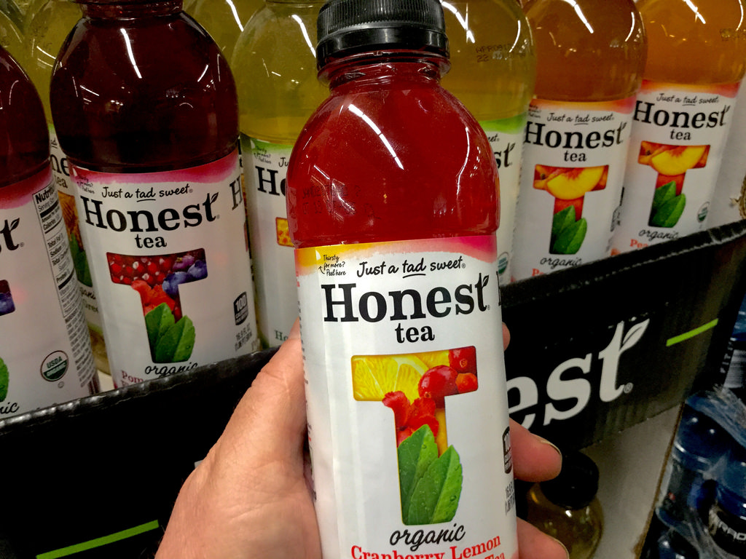

Market Segment

People who are physically active, between the ages of 15-35. This includes athletes, or anyone involved with sports/physical activity (coaches, parents of athletes).

Product:

**Honest Sport**, a twist on the typical sport drink that hydrates and refreshes.

Price:

Most sports drinks are sold anywhere from $1.00 to $2.19. As for Honest Sport, it is sold at $1.99 per 16.9 fl. oz bottle, which is slightly higher than Gatorade.

Promotion:

Since we have a sports drink, it would be best to promote it where people who play, watch, or coach sports are involved, so getting an advertisement in Sports Illustrated catalogs or on ESPN would be beneficial. Advertisements would grab the attention of those who are enthusiastic about sports, and wants to learn more about this unique sports drink.

Distribution:

Since Honest Sport is targeted for physically active people, one place that we could distribute the drinks are vending machines at gyms, as well as sports department stores (Modell's, Dick’s Sporting Goods). One other place that we could distribute the drinks are athletic complexes, at the counters. Many athletes train at athletic complexes, so by distributing them there it would make the drinks readily available.

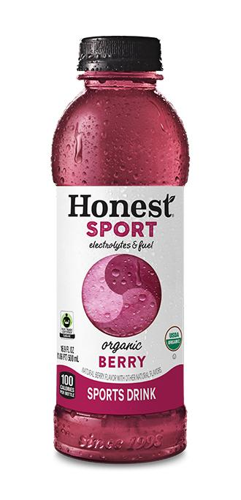

Market Segment

Parents between the ages of 25-40, with an income of $30k or more, with children between the ages of 3-13 who don’t want their kids to be drinking typical sodas or sweet drinks with artificial colors/sugars.

Product:

**Honest Kids**, a healthy fruit juice specially made for kids.

Price:

Honest Kids drinks come in packages, like Capri Sun. Honest Kids charges $20.00 for 32 pack - 6.75 fl. oz. This price is similar to other kids drinks, but priced slightly higher. Capri Sun charges $22.83 for a pack of 40 6 fl. oz. drinks.

Promotion:

Since this is a kids drink, an effective place to promote the beverages would be daytime tv cartoon stations, Disney channel, Nickelodeon, and Freeform. Not only will the kids see the juices, but parents will too since they are most likely with the kids, watching too.

Distribution:

While Starbucks is a coffee shop mainly for adults, we could distribute Honest

Kids there. While a parent buys coffee at Starbucks on their way to work, they could buy an Honest Kid beverage for their child if they were to drop off the child at school. One place that we could distribute the product is kids attractions like Chuck e Cheese, arcades, and sports complexes. Again places like Whole Foods and Trader Joe's would be good places to distribute the product since those stores specialize in organic foods and drinks, and parents buy the kinds of foods/drinks that they want their kids to have.

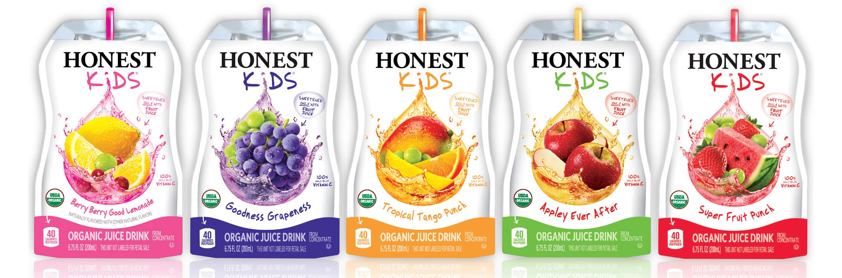

Market Segment

People who enjoy the taste of soda, but who are conscious of harmful ingredients and are concerned about the effects of typical sodas. Although the ages of people who like fizzy drinks varies, people with incomes of $20k or more are the market for Honest Fizz.

Product:

**Honest Fizz**, a healthy version of a typical soda.

Price:

Honest Fizz charges anywhere from $6.60 - $8.00 for 6 pack - 12 fl. Oz. This price is higher than a typical seltzer water like La Croix, which charges $3.50 for an 8-pack of 12 fl. oz. drinks.

Promotion:

As many people are becoming more aware of soda’s effects yet still love the taste, celebrity endorsements would be helpful to promote Honest Fizz. Advertisements on E! or other popular television channels like TLC or MTV would catch the eye of many people. Big Box store catalogs and “Six Flags” type promotions would also be beneficial.

Distribution:

Honest Fizz could be distributed any place a typical soda/seltzer would, so vending machines, Walmart, and restaurants would be good places to distribute the drinks. Vending machines are quick and convenient, Walmart’s are very popular and have many locations, and many restaurants offer seltzers and sodas.

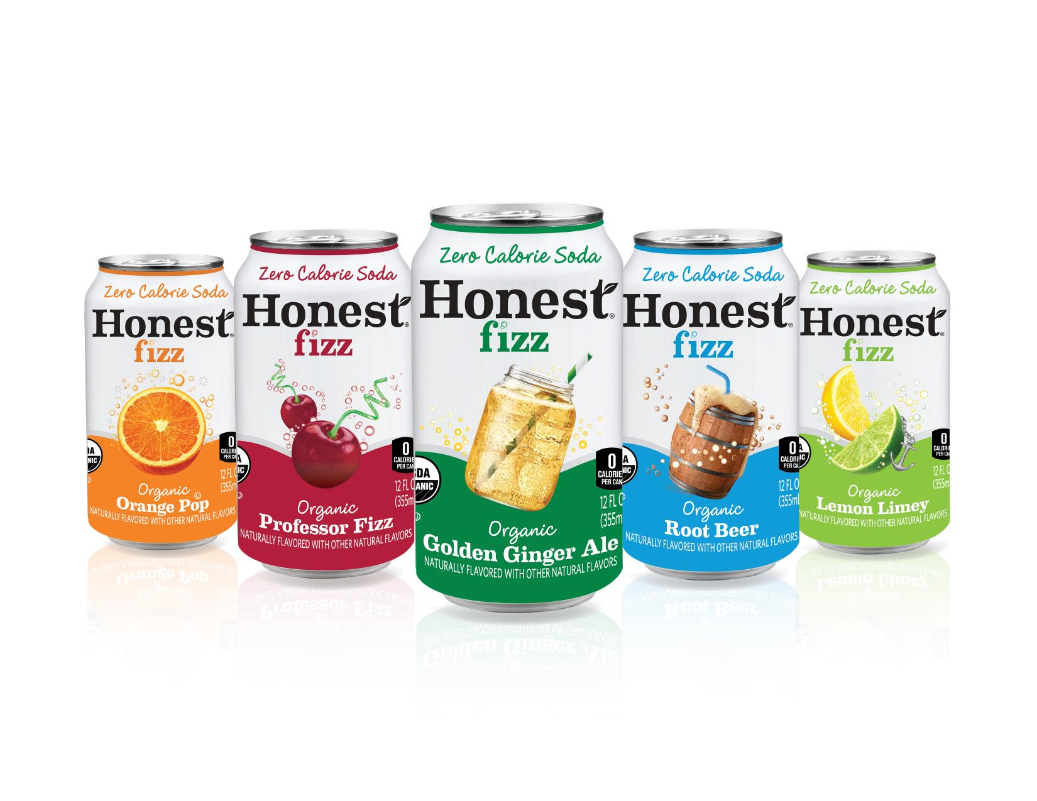

Works Cited

“Honest Tea.” *Honest Tea*, [www.honesttea.com/products/](http://www.honesttea.com/products/).

Https://www.facebook.com/CNBC. "How Honest Tea Conquered the US Beverage Market." *CNBC*. CNBC, 2015. Web. 05 Dec. 2016.